# M1. Digital logic circuits

How are digital logic circuits made and how are they used to build Boolean functions and higher level functions? Keywords: transistor, dissipation, logic gates, truth tables.

Basics of a chip is the transistors, these transistors always have to lines of power e.g. 0 and 5 volts, which works as switches outputting 0 or 1.

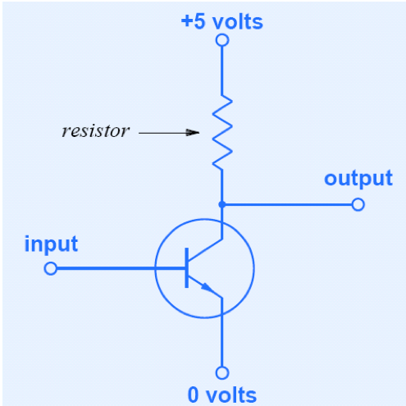

Transistors can create logic gates, e.g. NOT/INVERT, AND, OR, Not AND and Not OR, which can be combined in series.

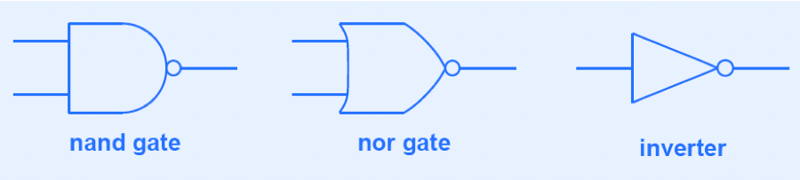

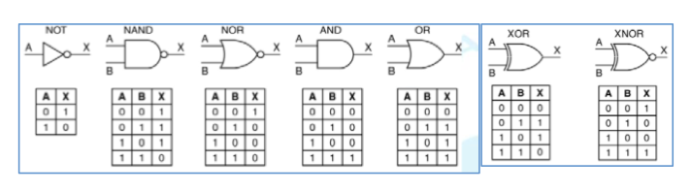

When designing a function, optimize it and make a truth table, build a circuit from that.

**Filp-flop**, e.g. when you start the computer you activate a bit, until this bit has been reset and activated again the filp-flop won’t change.

**Counter** can be three bits denoting a value which increases.

**Clock** used to activate a flip-flop or a counter, can be used to start a sequence e.g. computer startup.

